**AUCTION**

**DOCUMENTATION**

*Submitted by:*

ASHISH KUMAR SAHOO

*In partial fulfillment for the award of the master degree*

*Of*

Master of computer applications

IN

Computer science

RIMS, ROURKELA

**ABSTRACT:**

Auction project that holds various products on a website and serves seller and bidders accordingly.

The system is designed to allow users to set up their products for auctions and bidders to register and bid for various products available for bidding.

**Auction part:**

**Bidder login:**

Here the buyer or the product bidder can see a list of products up for bidding and place his/her bid on the product.

**Seller login:**

This is the seller module where the seller posts a product up for auctions.

**Admin Login:**

This module is for the administrator who may delete fake or unwanted ads.

**Report generation:**

Admin gets a report whenever wanted starting various product up for bidding and various users registered on the website.

***Introduction:***

Auction means Latin work, which means growth. Auction is a bid, a method of selling; Purchasing and providing services occur. The online auction system has many other names such as e-auction and electronic auction. The client can more accurately specify the need for online auctions or online bidding. Online bidding has become more widespread in all forms of industrial use. Not only does it have the product or goods it needs to sell, it also has the services it can offer. Due to their low cost, this spread caused the system to thrive.

Preferred bidders can manage and monitor the same database. The user’s data may be maintained confidentially for the validity and integrity of the contract documentation. Multiple babies can communicate very easily. This system allows multiple bids by single users. Developing a user-friendly auction site where any product can be bid and providing value-added services to bidders and sellers. The world of online auctions Marketplaces allow buyers and sellers to cross geographical limits and purchase products from anywhere over the Internet

. The online auction market offers consumers lower prices, greater product selectivity and greater efficiency compared to traditional online markets (Ghose et al., 200!). Seller's choice and the product they produce make greater buyer certainty. It consists of three components: seller rating scores and seller's shilling operations. Certifications, description of product characteristics, product usage and book value. It seeks to ensure buyers product accuracy. Decision Assistance tool also provides seller ratings by using Feedback Scores. These feedbacks give previous winning bidders and evaluate online auction product vendors. These bidders give detailed seller ratings of all aspects of the seller, and give scores for how accurate the description of the item is, how satisfied they are with the seller's communication, and how quickly the seller is shipped to them.

***HARDWARE AND SOFTWARE REQUIREMENTS:ABSTRACT:ABSTRACT:ABSTRACT:ABSTRACT:ABSTRACT:ABSTRACT:***

**SOFTWARE REQUIREMENTS :**

* Technology : Python Django
* IDE : Pycharm
* Client Side Technologies : HTML,CSS, JavaScript, Bootstrap
* Server side technology :Python
* Database Server : Sqlite
* OS : Window 11

**HARDWARE REQUIREMENTS :**

* Processer : Pentium-III
* RAM : 64MB
* Hard disk : 50GB

PURPOSE:

The purpose is to develop a user friendly auctioning site where product can be auctioned and provide value-added services to the bidders and the sellers.

Secure registration for all users including a personal profile.

Another purpose for developing this application is to generate the report automatically.

Implementation issues:

Python:

Python is a programming language that lets you work quickly and integrate system more efficiently.

Python is dynamically typed and garbage-collected. It support multiple programming paradigms, including procedural , object-oriented and functional programming. Python is often described as a “batteries included” language due to its comprehensive standard library.

HTML:

HTML is the set of markup symbols or codes inserted in a file intended for display on a www page. The markup tells the Web browser how to display a web page’s words and images for the user. Each individual markup code is referred to as an element. Some elements come in pairs that indicate when some display effect is to begin and when it is to end.

CSS :

CSS are a collection of rules we use to define and modify web pages. CSS are similar to style in word. All you need to do is redefine the style on the style sheet, and it will instantly change on all of the pages that the style sheet has been applied to. With HTML styles, the font change would be applied to each instance of that font and have to be changed in each spot.

JavaScript :

JavaScript is a client-side scripting language, which means the source code is processed by the client’s web browser rather than the web server. This means JavaScript functions can run after the web page loaded without COMMUNICATING with the server.

Django :

Django is a web application framework written in Python programming language. It is bases on Model view Template design pattern. The Django is very demanding due to its rapid development feature. It takes less time to build application after collecting client requirement.

This framework is used a famous tag line.

SYSTEM DESIGN

Use case diagram

Class diagram

Sequence diagram

Use case diagram

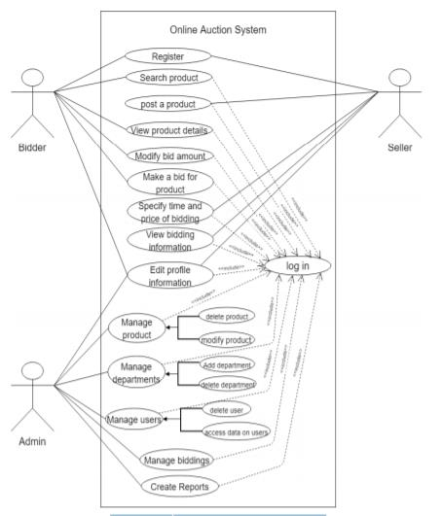

This diagram consists of use cases and actors and shows the interaction between them.

The main purpose is to show the interaction between the use cases and the actor.

The use cases are the functions that are to performed in the module.

Class diagram :

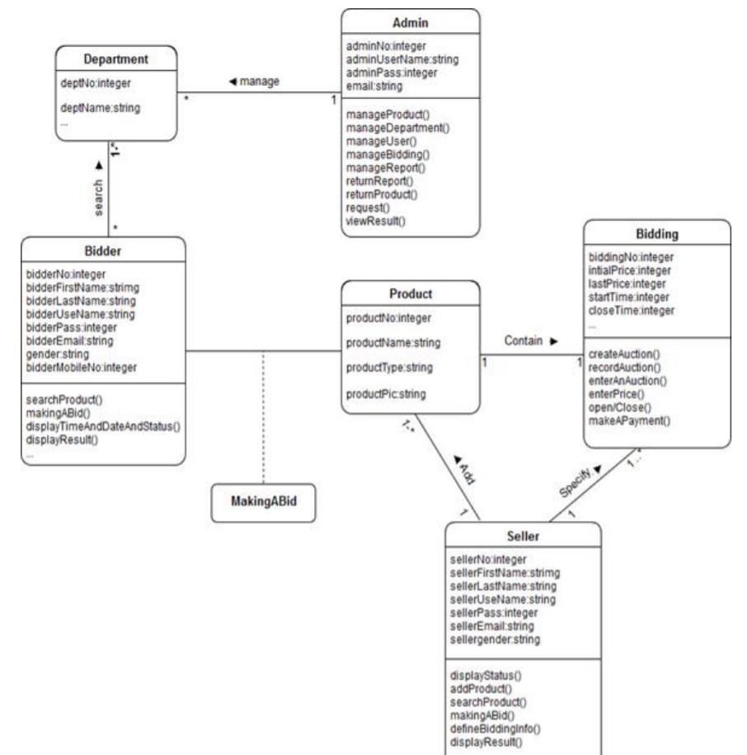

Sequence diagram :

